

**COMPUTER ENGINEERING**

**CG ODD SEM 2021-22/EXPERIMENT 7 NAME:- GAURAV AMARNANI (D7A, 67)**

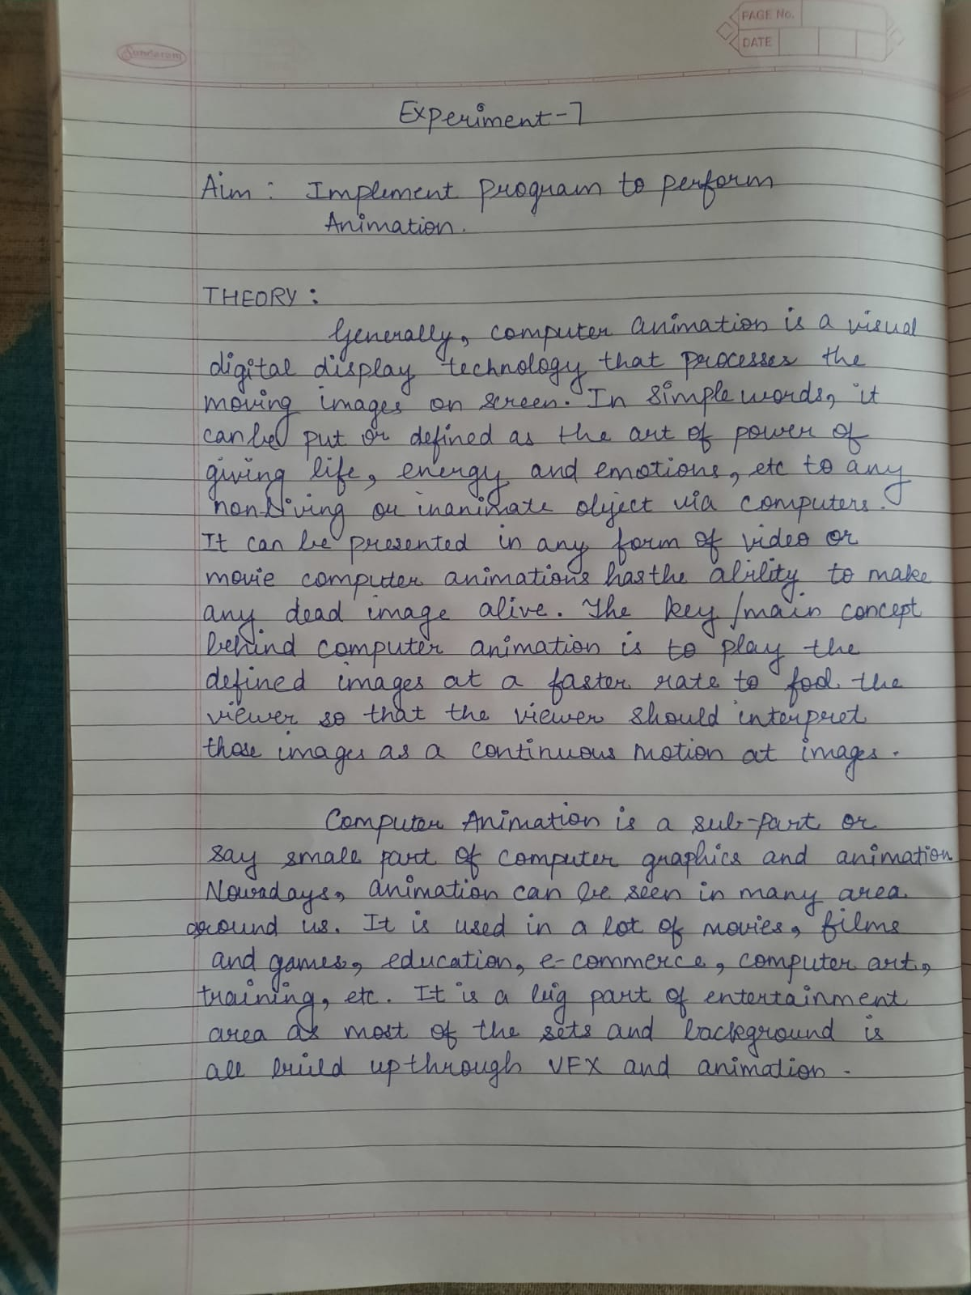

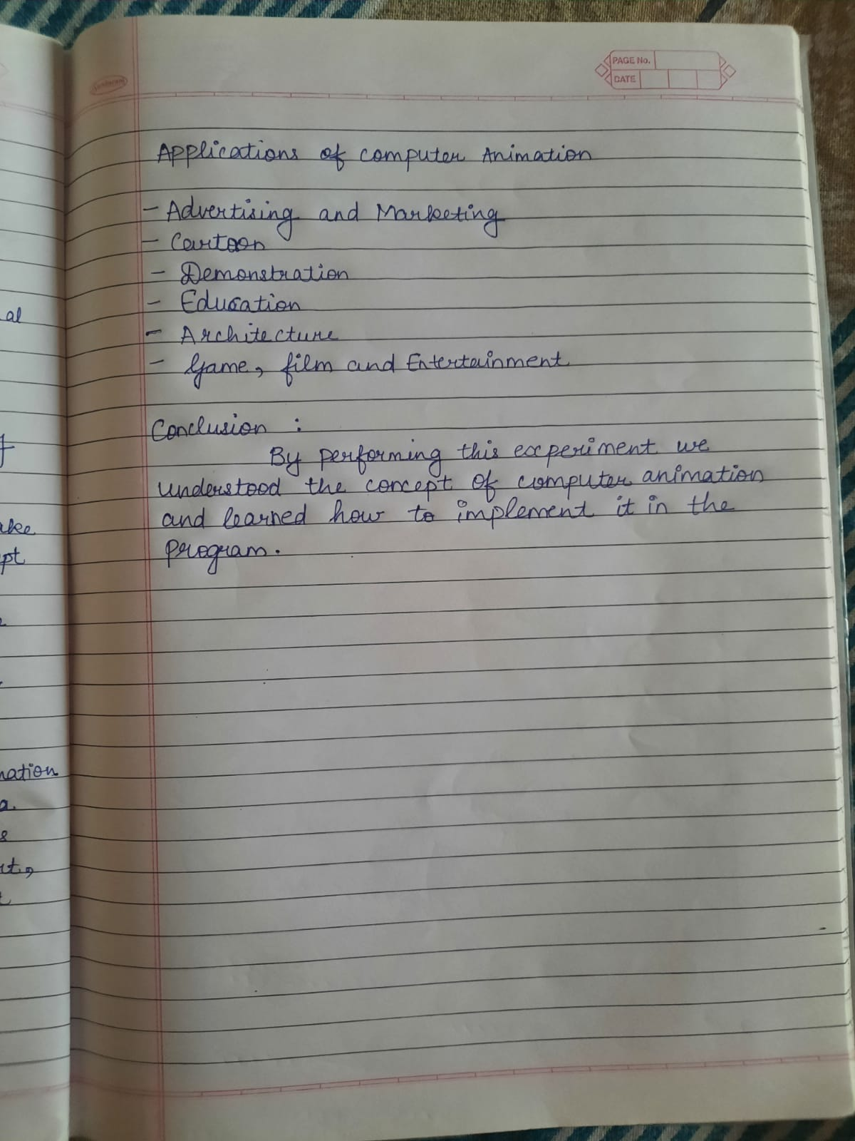

Program:

#include<graphics.h>

#include<conio.h>

#include<stdlib.h>

void main() {

int gd = DETECT, gm, area, temp1, temp2, left = 25, top = 75;

void *p;

initgraph(&gd, &gm, "C:\\TURBOC3\\BGI");

setcolor(YELLOW);

circle(50, 100, 25);

setfillstyle(SOLID_FILL, YELLOW);

floodfill(50, 100, YELLOW);

setcolor(BLACK);

setfillstyle(SOLID_FILL, BLACK);

fillellipse(44, 85, 2, 6);

fillellipse(56, 85, 2, 6);

ellipse(50, 100, 205, 335, 20, 9);

ellipse(50, 100, 205, 335, 20, 10);

ellipse(50, 100, 205, 335, 20, 11);

area = imagesize(left, top, left + 50, top + 50);

p = malloc(area);

setcolor(WHITE);

settextstyle(SANS_SERIF_FONT, HORIZ_DIR, 2);

outtextxy(155, 451, "Smiling Face Animation");

setcolor(BLUE);

rectangle(0, 0, 639, 449);

while(!kbhit()) {

temp1 = 1 + random (588);

temp2 = 1 + random (380);

getimage(left, top, left + 50, top + 50, p);

putimage(left, top, p, XOR_PUT);

putimage(temp1 , temp2, p, XOR_PUT); delay(100);

left = temp1; top = temp2;

}

getch();

closegraph();

}

Output:

